**Experiment No:** 10

**Experiment name:**  Preemptive SJF Algorithm

**Advantages:**

i.Minimum average waiting time is achieved.

ii.The throughput time is good as the burst time of the processes is less.

iii.optimum turnaround time.

Source Code:

#include <stdio.h>

int main()

{

int arrival_time[10], burst_time[10], temp[10];

int i, smallest, count = 0, time, limit;

double wait_time = 0, turnaround_time = 0, end;

float average_waiting_time, average_turnaround_time;

printf("\nEnter the Total Number of Processes:\t");

scanf("%d", &limit);

printf("\nEnter Details of %d Processes\n", limit);

for(i = 0; i < limit; i++)

{

printf("\nEnter Arrival Time:\t");

scanf("%d", &arrival_time[i]);

printf("Enter Burst Time:\t");

scanf("%d", &burst_time[i]);

temp[i] = burst_time[i];

}

burst_time[9] = 9999;

for(time = 0; count != limit; time++)

{

smallest = 9;

for(i = 0; i < limit; i++)

{

if(arrival_time[i] <= time && burst_time[i] < burst_time[smallest] && burst_time[i] > 0)

{

smallest = i;

}

}

burst_time[smallest]--;

if(burst_time[smallest] == 0)

{

count++;

end = time + 1;

wait_time = wait_time + end - arrival_time[smallest] - temp[smallest];

turnaround_time = turnaround_time + end - arrival_time[smallest];

}

}

average_waiting_time = wait_time / limit;

average_turnaround_time = turnaround_time / limit;

printf("\n\nAverage Waiting Time is:\t%lf\n", average_waiting_time);

printf("Average Turnaround Time is:\t%lf\n", average_turnaround_time);

return 0;

}

Result:

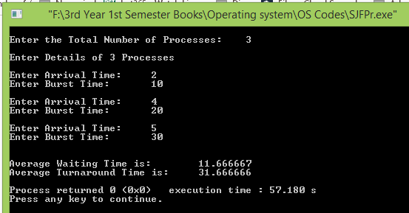

Conclusion:

This scheduling algorithm, the process with the smallest amount of time remaining until completion is selected to execute. Since the currently executing process is the one with the shortest amount of time remaining by definition, and since that time should only reduce as execution progresses, processes will always run until they complete or a new process is added that requires a smaller amount of time.